Revision 3: Automated systems, AI and logic - Student booklet
Y11 - Cambridge IGCSE Computer Science 0478 | Exam revision
Name: _______________________________ | Date: _____________

- Learn sections are your revision notes: read them carefully, then do the task straight after.
- Task 1 is a closed-book recall test - do it from memory first.
- Questions with a paper reference are real Cambridge 0478 questions. Your teacher will share the answers.
Task 1 Recall test on Revision 2 (closed book) [10 marks]
# | Question | Answer
1 | Which register holds the address of the next instruction?
2 | Which bus carries data in both directions?
3 | Give one effect of increasing cache size.
4 | Which translator converts assembly language into machine code?
5 | Give one difference between a compiler and an interpreter.
6 | What does DNS stand for?
7 | Where is a session cookie stored?
8 | How many bits are in an IPv6 address?
9 | Who assigns a MAC address?
10 | Name one security solution that helps prevent a DDoS attack.
Learn Automated systems and robots
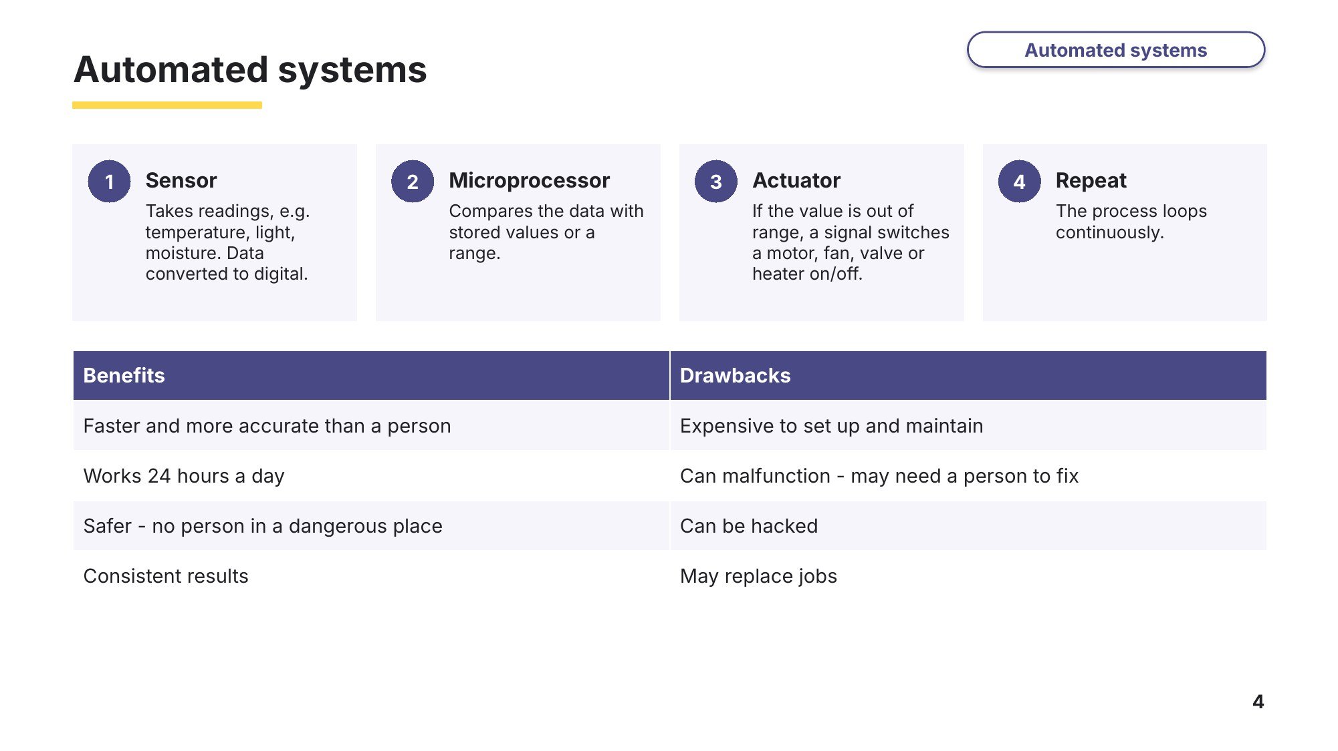
Slide 4 - Automated systems
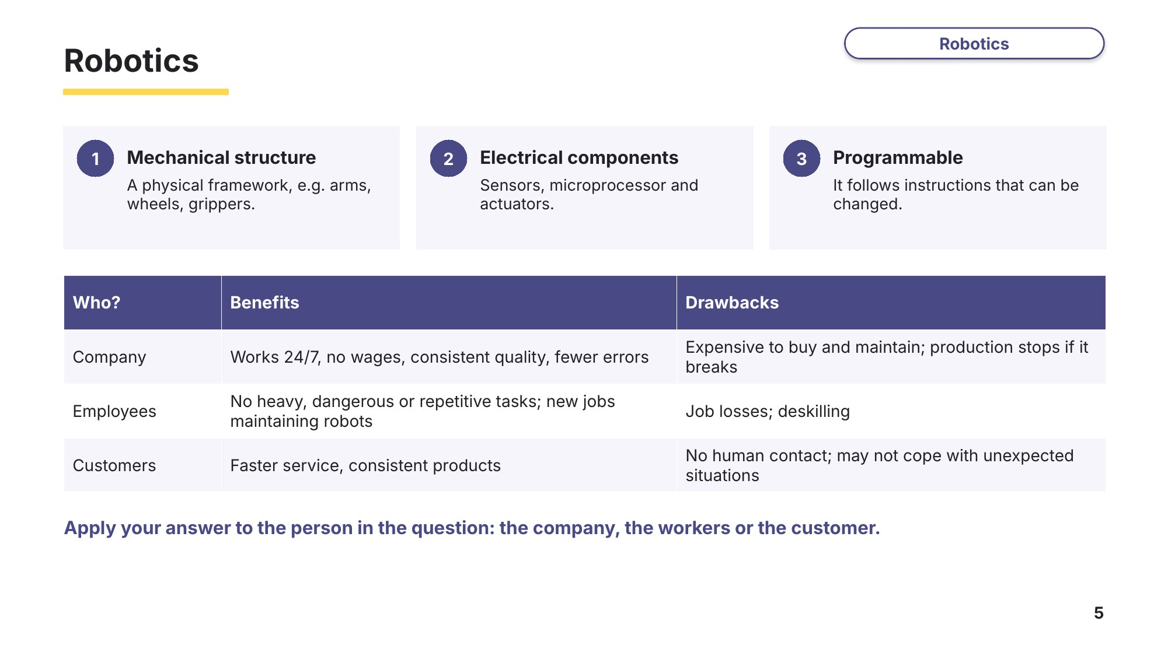
Slide 5 - Robotics
Task 2 Automated systems and robots [18 marks]
2A Robots in a furniture factory
0478/11 May/June 2023 Q9
A company uses robots in its factory to manufacture large pieces of furniture.
(a) One characteristic of a robot is that it is programmable. State two other characteristics of a robot. [2]
1

2

(b) Give two advantages to company employees of using robots to manufacture large pieces of furniture. [2]
1

2

(c) Give one disadvantage to the company’s owners of using robots to manufacture large pieces of furniture. [1]

2B Robots in a car factory
0478/11 May/June 2025 Q8
A robot is used to move car parts in a factory.
(a) One characteristic of the robot is that it has a mechanical structure. Give one other characteristic of a robot. [1]

(b) The robot has firmware. State what is meant by firmware. [1]

(c) Interrupts are generated when the robot is operating in the factory. Give two examples of interrupts that may be generated when the robot is in operation. [2]
1

2

(d) Give two advantages to the workers in the factory of using robots to move the car parts. [2]
1

2

(e) The robots have the ability to automatically adapt their own processes. State the name of the ability described. [1]

2C Automated greenhouse (exam-style)
A plant nursery uses an automated system to keep the soil in a greenhouse moist. The system uses a moisture sensor, a microprocessor and a water valve.
(a) Explain how the automated system keeps the soil moist. [4]

(b) Give two drawbacks to the plant nursery of using the automated system. [2]
1

2

Learn AI and expert systems
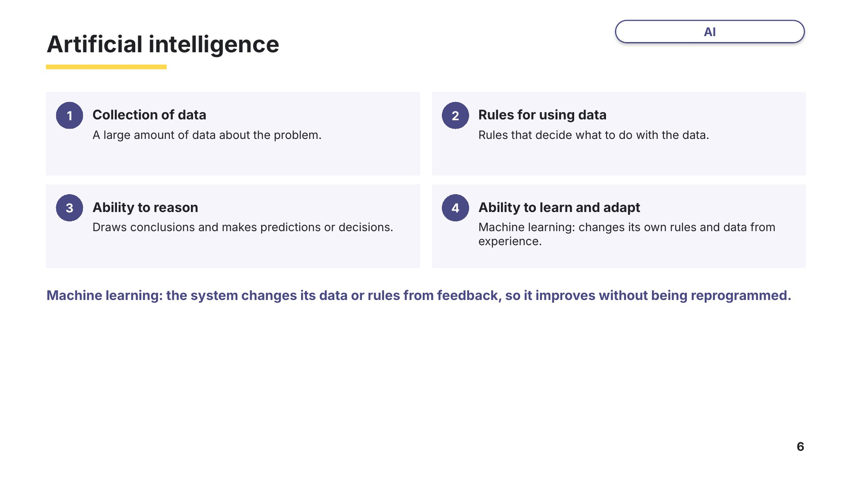
Slide 6 - Artificial intelligence
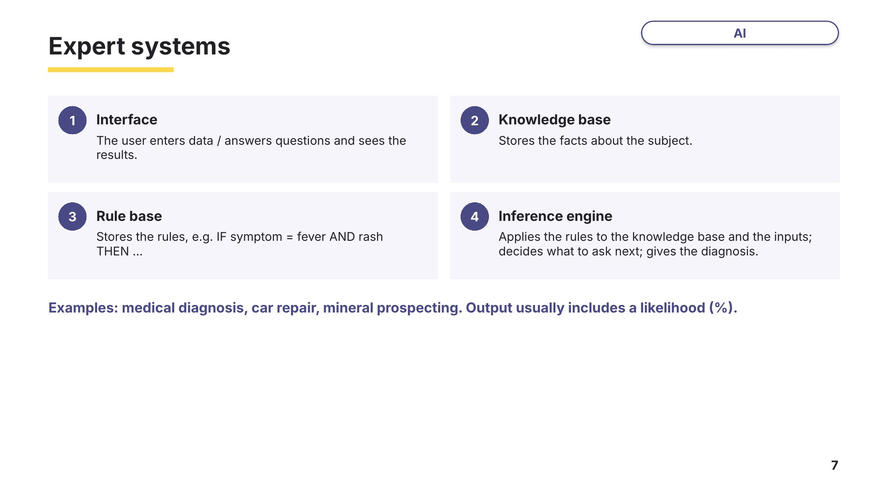
Slide 7 - Expert systems
Task 3 AI and expert systems [13 marks]
3A Expert systems
0478/12 October/November 2023 Q10
A business has a system that is described as having artificial intelligence (AI).
(a) State one of the main characteristics of an AI system. [1]

(b) An AI system is an expert system. Explain how an expert system operates. [6]

3B Machine learning in a search engine
0478/12 February/March 2025 Q6
A search engine uses artificial intelligence (AI) to identify the most relevant web pages for the user.
(a) One characteristic of AI is the ability to learn. Identify three other characteristics of AI. [3]
1

2

3

(b) The search engine uses machine learning. Explain how machine learning is used by the search engine. [3]

Learn Logic gates
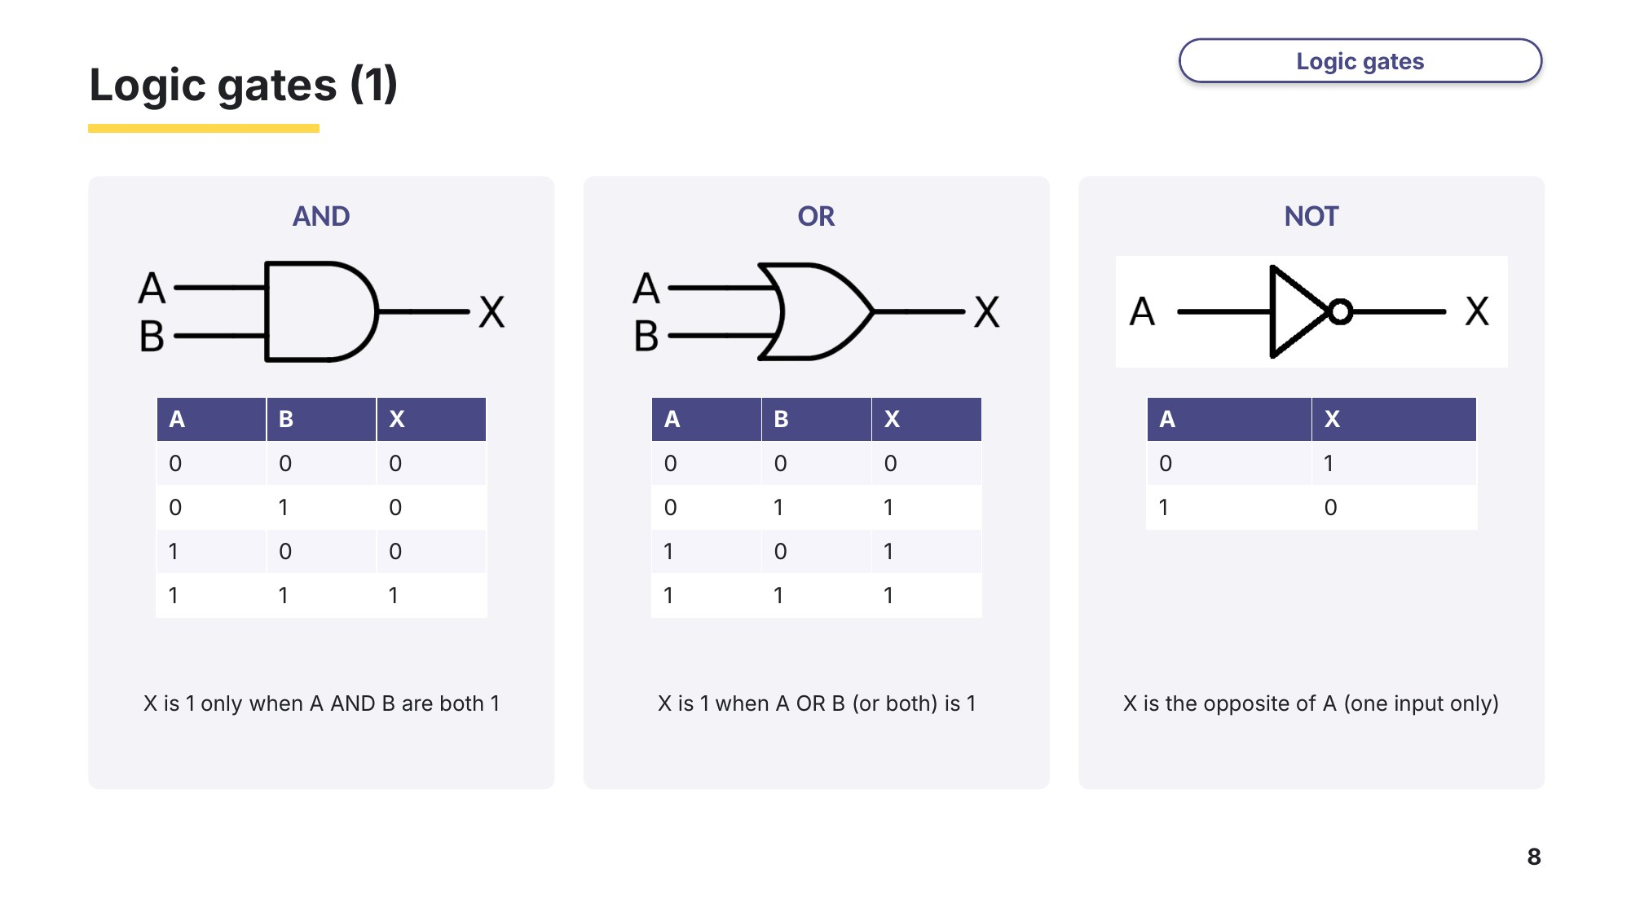
Slide 8 - Logic gates (1)
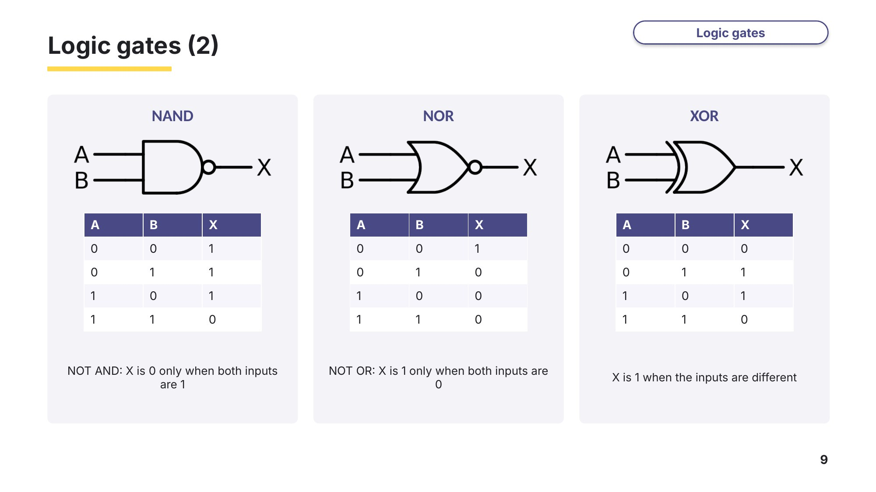
Slide 9 - Logic gates (2)
Task 4 Logic gates and truth tables [10 marks]
4A Identify the gates
0478/23 October/November 2023 Q6(a)-(c)
There are three descriptions of logic gates. Each logic gate has two inputs A and B with one output X. Identify each logic gate. Complete a truth table for each logic gate.
(a) The only time the output is 1 is when both inputs are 1. [2]
Logic gate ……………………………………
A | B | X
0 | 0
0 | 1
1 | 0
1 | 1
(b) The output is 1 when both inputs are different. [2]
Logic gate ……………………………………
A | B | X
0 | 0
0 | 1
1 | 0
1 | 1
(c) The only time the output is 1 is when both inputs are 0. [2]
Logic gate ……………………………………
A | B | X
0 | 0
0 | 1
1 | 0
1 | 1

4B Truth table from an expression
0478/22 May/June 2023 Q8
Consider this logic expression. X = (A OR B) AND (NOT B AND C)
Complete the truth table for this logic expression. [4]
A | B | C | Working space | X
0 | 0 | 0
0 | 0 | 1
0 | 1 | 0
0 | 1 | 1
1 | 0 | 0
1 | 0 | 1
1 | 1 | 0
1 | 1 | 1
Learn Logic circuits
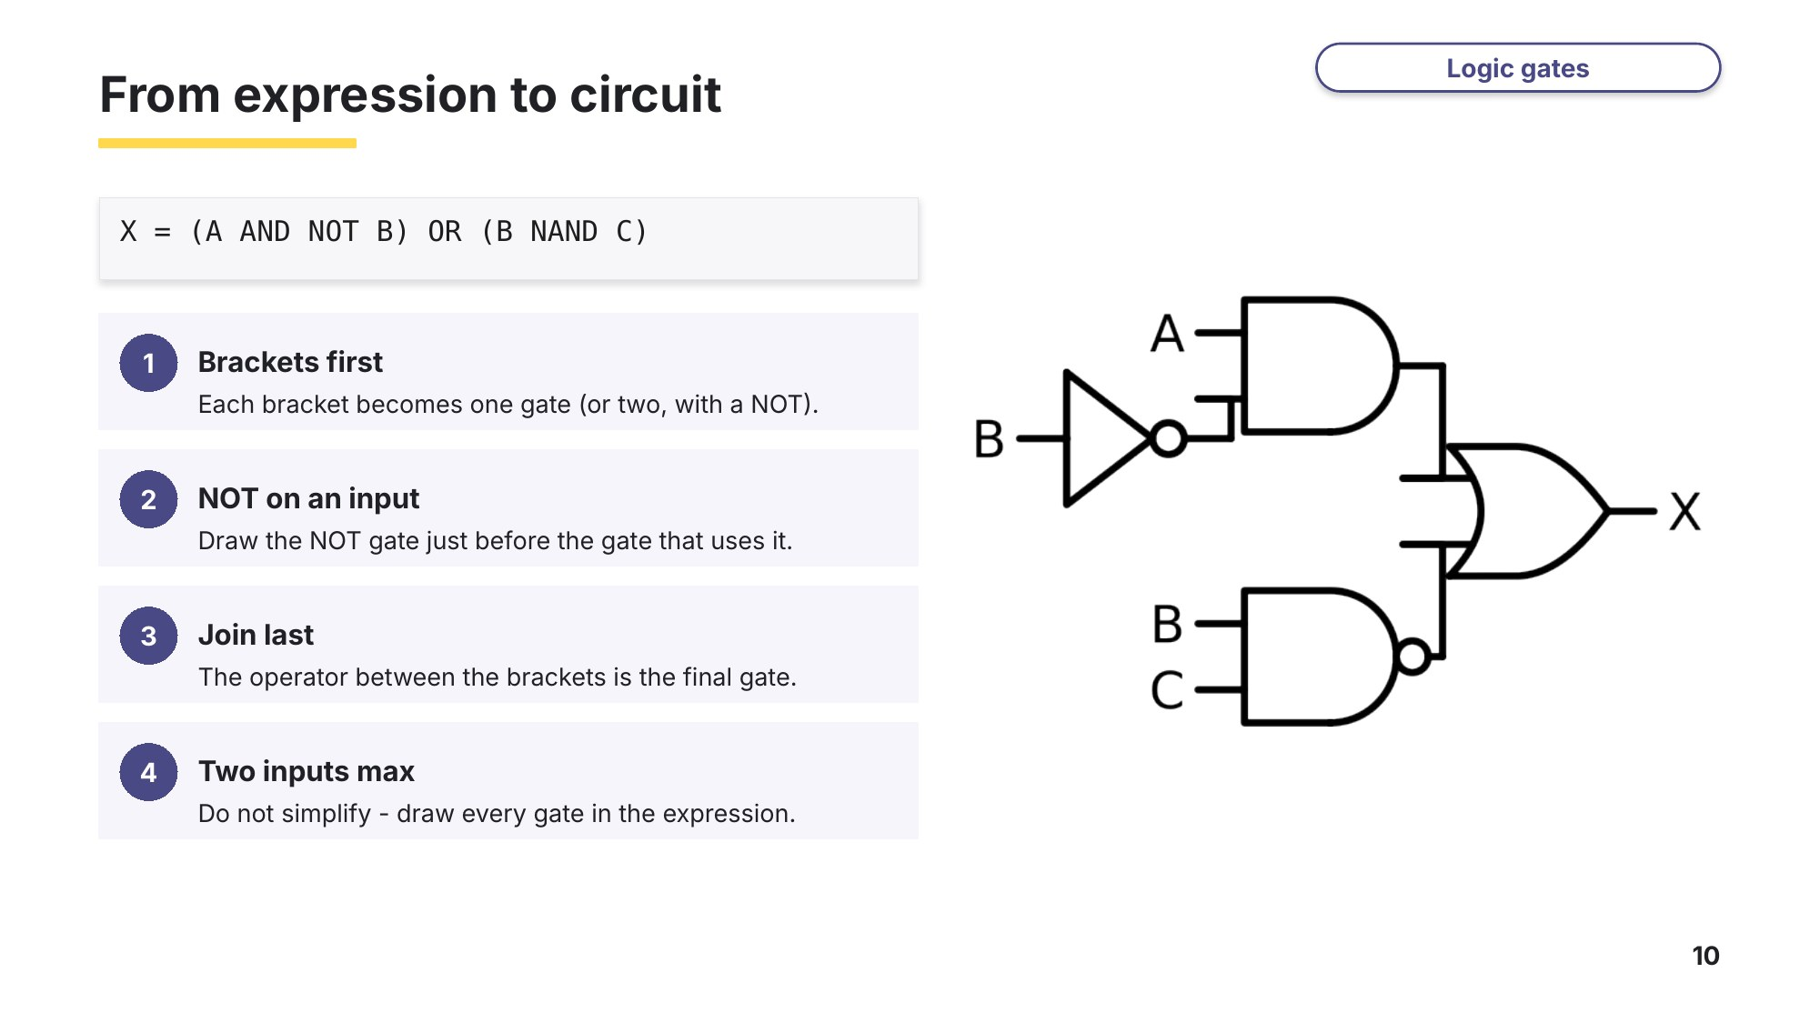
Slide 10 - From expression to circuit
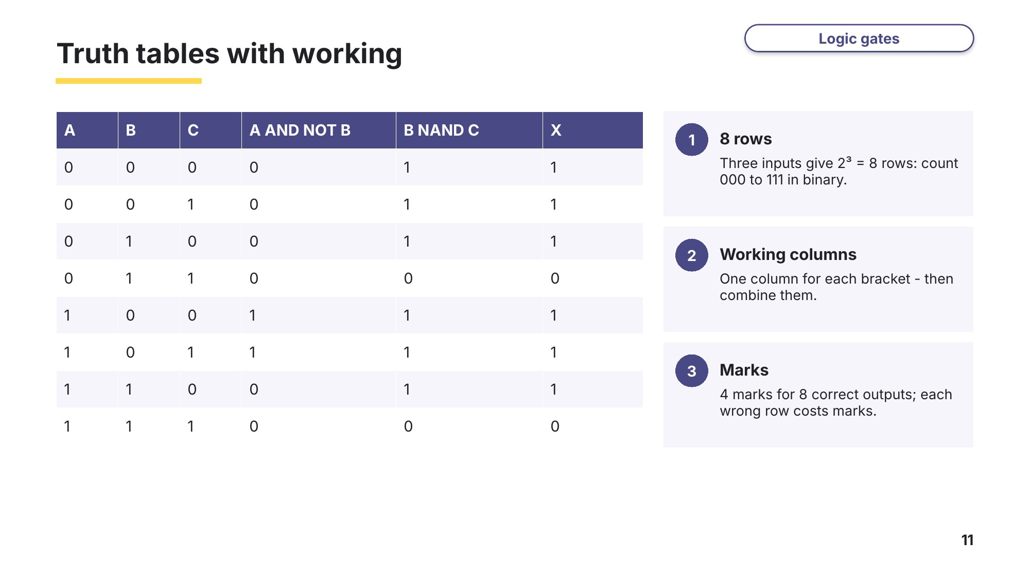
Slide 11 - Truth tables with working
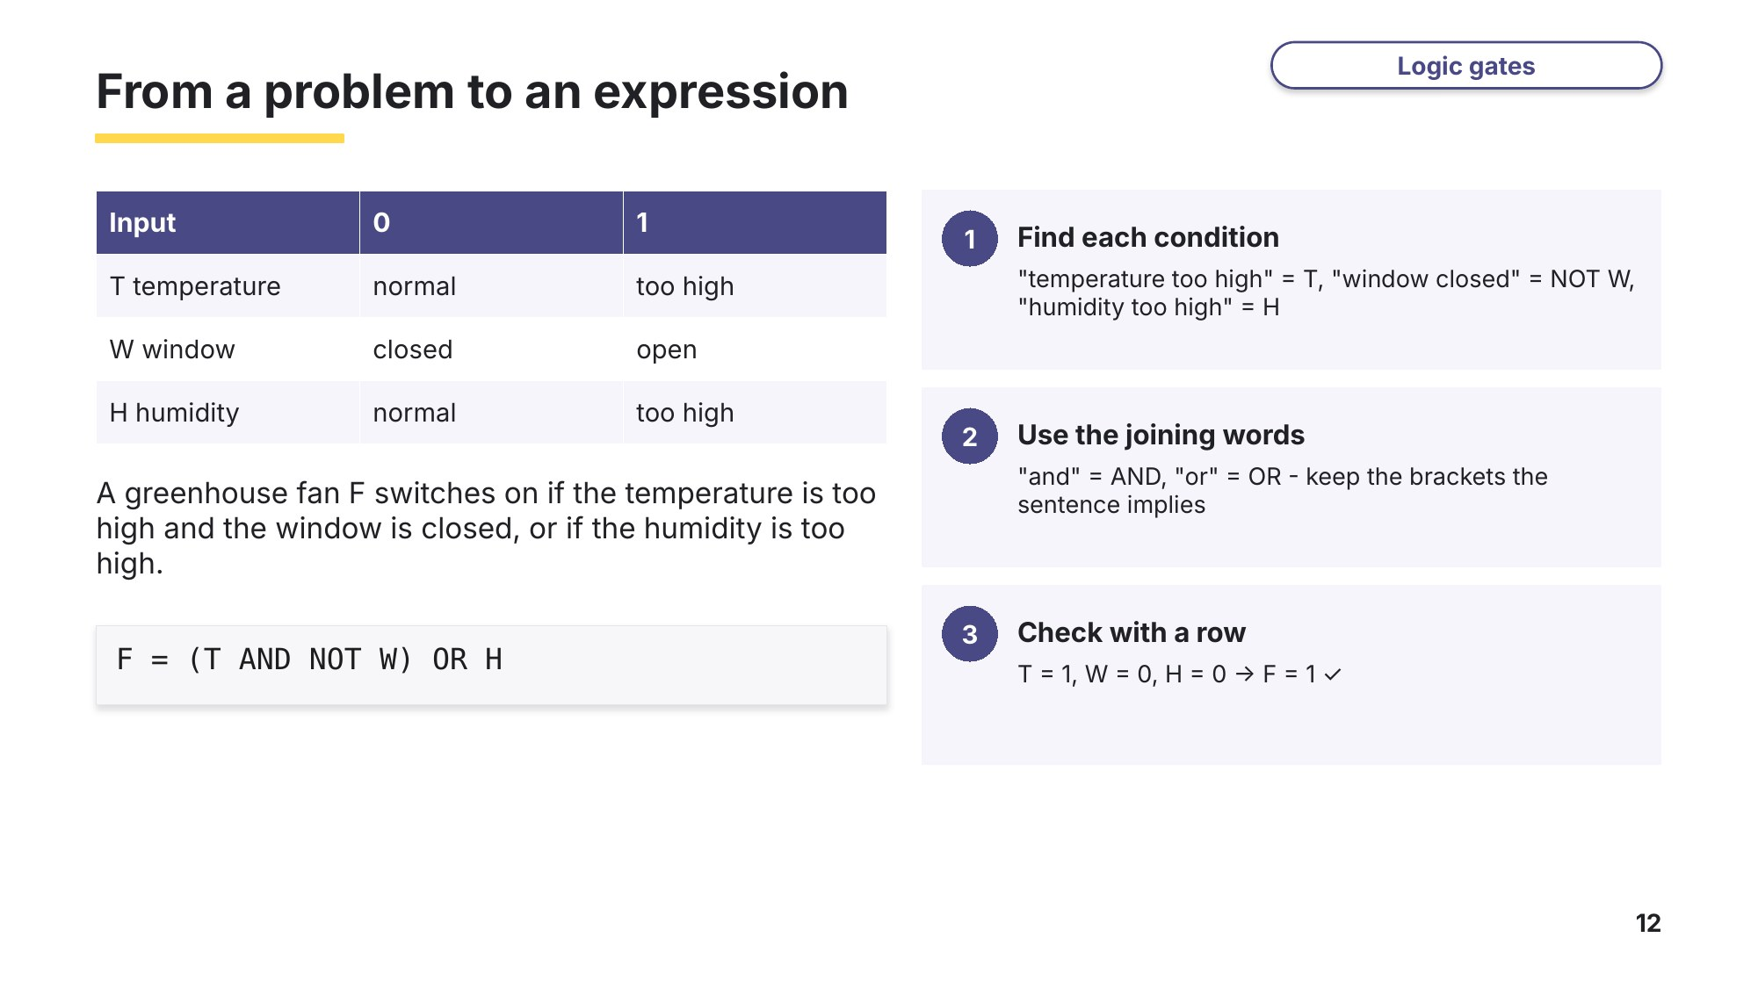
Slide 12 - From a problem to an expression
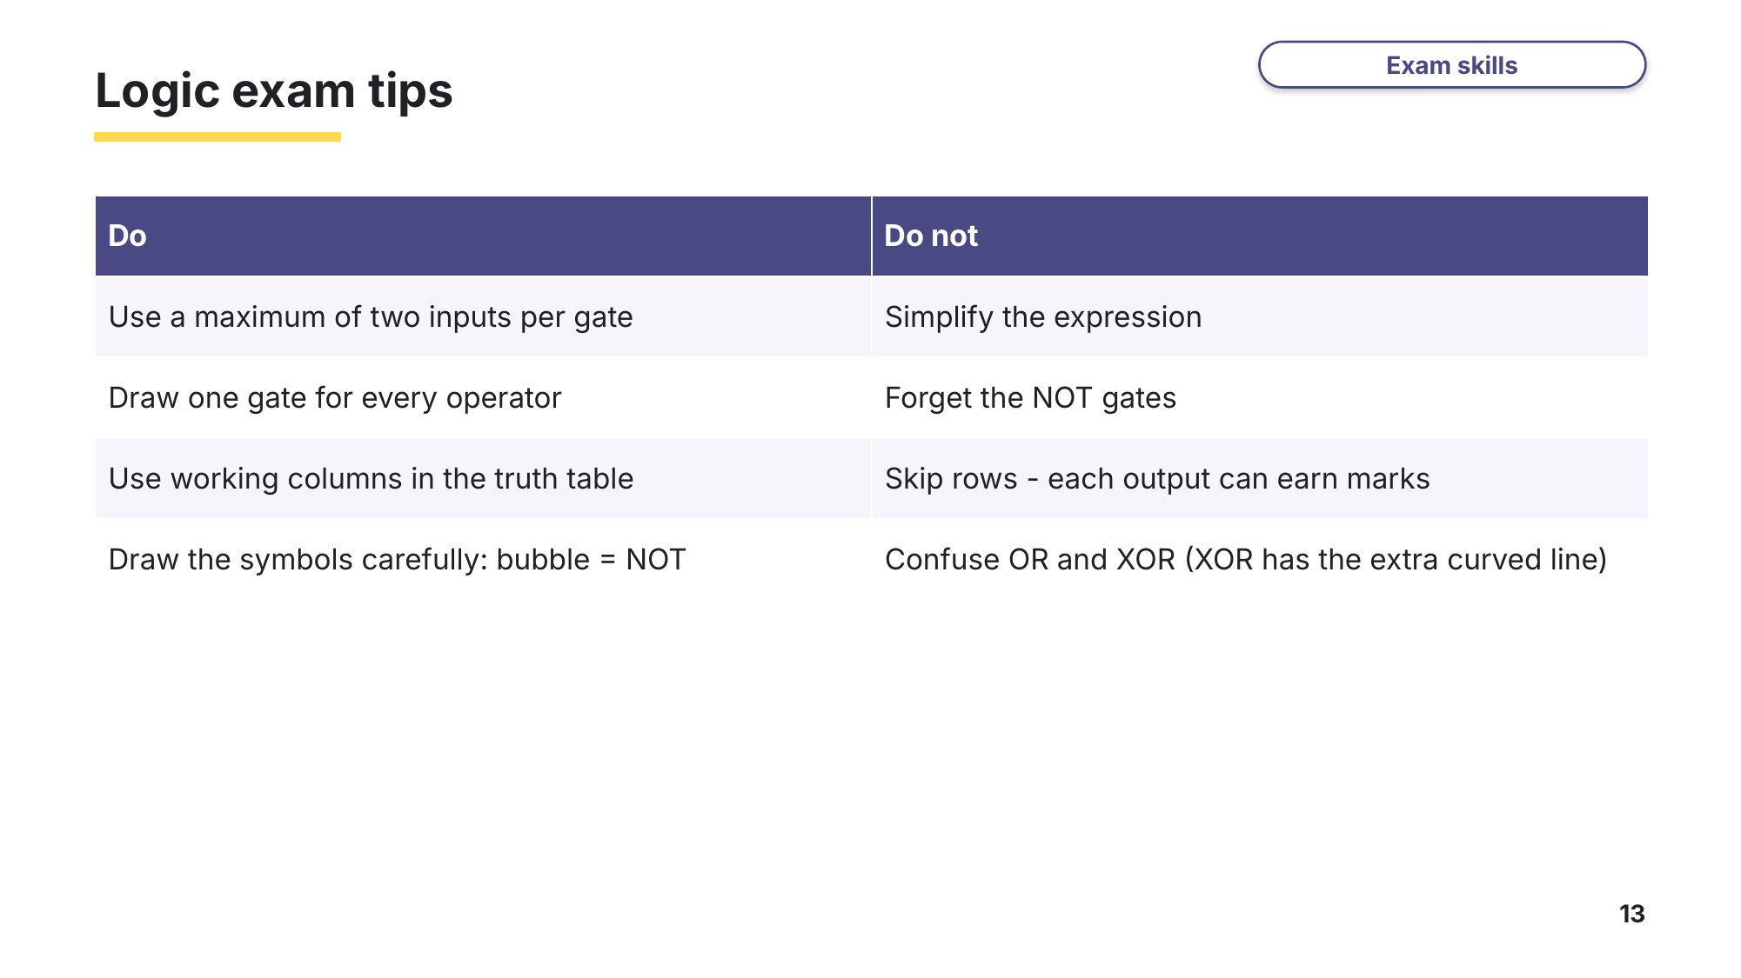
Slide 13 - Logic exam tips
Task 5 Logic circuits [23 marks]
5A NAND and XOR
0478/22 October/November 2024 Q9
Consider the logic expression: X = (NOT P OR Q) NAND (Q XOR R)
(a) Draw a logic circuit for this logic expression. Each logic gate must have a maximum of two inputs. Do not simplify the logic expression. [4]
P  Q  R |  | X
(b) Complete the truth table for the given logic expression. [4]
P | Q | R | Working space | X
0 | 0 | 0
0 | 0 | 1
0 | 1 | 0
0 | 1 | 1
1 | 0 | 0
1 | 0 | 1
1 | 1 | 0
1 | 1 | 1
5B AND, OR and XOR
0478/21 May/June 2025 Q7
Consider the logic expression: X = (A AND B) XOR (B OR NOT C)
(a) Draw a logic circuit for this logic expression. Each logic gate must have a maximum of two inputs. Do not simplify the logic expression. [4]
A  B  C |  | X
(b) Complete the truth table for the given logic expression. [4]
A | B | C | Working space | X
0 | 0 | 0
0 | 0 | 1
0 | 1 | 0
0 | 1 | 1
1 | 0 | 0
1 | 0 | 1
1 | 1 | 0
1 | 1 | 1
5C Opening a safe
0478/22 May/June 2024 Q8
A logic circuit is to be built to control the opening of a safe used to store money. There are two keys, A and B, and a time switch C. The safe can only open if both keys are used and the time switch is off.
Input / output | 0 | 1
key A | not used | used
key B | not used | used
time switch C | switch off | switch on
safe X | safe cannot open | safe can open
(a) Write the logic expression for this problem. [3]

(b) Complete the truth table for this problem. [4]
A | B | C | Working space | X
0 | 0 | 0
0 | 0 | 1
0 | 1 | 0
0 | 1 | 1
1 | 0 | 0
1 | 0 | 1
1 | 1 | 0
1 | 1 | 1
Task 6 Extension: more logic circuits [13 marks]
6A NOT gates
0478/23 October/November 2023 Q6(d)
Consider this logic expression: X = (NOT A OR NOT B) OR NOT C
Draw a logic circuit for this logic expression. Each logic gate must have a maximum of two inputs. Do not attempt to simplify this logic expression. [5]
A  B  C |  | X
6B NOR and XOR (exam-style)
Consider the logic expression: Y = (A NOR B) OR (B XOR NOT C)
(a) Draw a logic circuit for this logic expression. Each logic gate must have a maximum of two inputs. Do not simplify the logic expression. [4]
A  B  C |  | Y
(b) Complete the truth table for the given logic expression. [4]
A | B | C | Working space | Y
0 | 0 | 0
0 | 0 | 1
0 | 1 | 0
0 | 1 | 1
1 | 0 | 0
1 | 0 | 1
1 | 1 | 0
1 | 1 | 1

